Project Planning Phase
Project Planning Template (Product Backlog, Sprint Planning, Stories, Story points)
Date | 3 October 2026
Team ID | SWTID-2026-9505
Project Name | Implement Client Script & UI Policy (Incident)
Maximum Marks | 5 Marks

Product Backlog, Sprint Schedule, and Estimation (4 Marks)
Sprint | Functional Requirement (Epic) | User Story Number | User Story / Task | Story Points | Priority | Team Members
Sprint-1 | UI Policy on Incident | USN-1 | As an administrator, I can create the “High Impact Control” UI Policy on the Incident table (Impact is 1 – High) so that extra controls apply to high-impact incidents. | 2 | High | Venthan B
Sprint-1 | UI Policy Action – Urgency | USN-2 | As an administrator, I can configure a UI Policy Action that makes the Urgency field read-only when Impact is High. | 5 | High | Venthan B
Sprint-1 | onChange Client Script | USN-3 | As an administrator, I can create an onChange client script that automatically sets Urgency to High when Impact is changed to High. | 3 | Medium | Sajeevatharan S
Sprint-1 | onSubmit Client Script (Save Validation) | USN-4 | As an administrator, I can create an onSubmit client script that prevents saving a high-impact incident when Assigned To is empty. | 3 | High | Sajeevatharan S
Sprint-1 | onCellEdit Client Script | USN-5 | As an administrator, I can create an onCellEdit client script that blocks changing the State field directly from the list view. | 3 | Medium | Jeeva S
Sprint-2 | Testing the Configuration | USN-6 | As a tester, I can verify that an incident with High impact cannot be saved without Assigned To (mandatory enforcement). | 1 | Medium | Jeeva S
Sprint-2 |  | USN-7 | As a tester, I can verify that an incident saves successfully once Assigned To is filled in. | 1 | Medium | Rohith G
Sprint-2 |  | USN-8 | As a tester, I can verify that the field changes revert when the Impact condition is no longer met (reverse condition). | 1 | Medium | Rohith G
Sprint-2 |  | USN-9 | As a tester, I can verify that the State field cannot be edited directly from the incident list. | 1 | Medium | Rakesh K
Sprint-2 |  | USN-10 | As a tester, I can verify that the State field can still be updated from the incident form. | 1 | Medium | Rakesh K
Sprint-2 | Conclusion | USN-11 | As a team member, I can document the outcome of the configuration and testing as the project conclusion. | 1 | Low | Venthan B

Project Tracker, Velocity & Burndown Chart: (4 Marks)
Sprint | Total Story Points | Duration | Sprint Start Date | Sprint End Date (Planned) | Story Points Completed (as on Planned End Date) | Sprint Release Date (Actual)
Sprint-1 | 16 | 6 Days | 21 Sep 2026 | 26 Sep 2026 | 16 | 26 Sep 2026
Sprint-2 | 6 | 6 Days | 28 Sep 2026 | 03 Oct 2026 | 6 | 03 Oct 2026

Velocity:
Total story points completed = 16 + 6 = 22 over 2 sprints, so the team’s velocity is 22 / 2 = 11 story points per sprint.
With a 6-day sprint duration and a velocity of 11 (points per sprint), the team’s average velocity (AV) per iteration unit (story points per day) is:
AV = velocity / sprint duration = 11 / 6 ≈ 1.83 story points per day
Burndown Chart:
A burn down chart is a graphical representation of work left to do versus time. It is often used in agile software development methodologies such as Scrum. However, burn down charts can be applied to any project containing measurable progress over time.
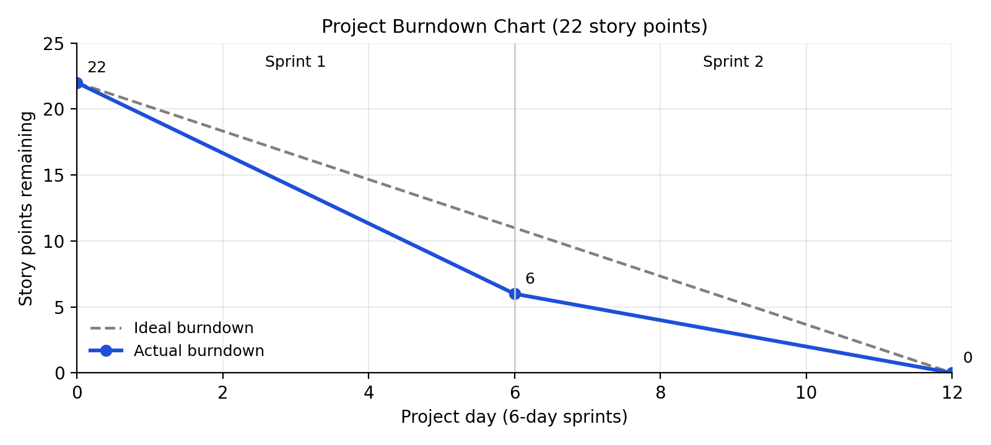
Reference:
https://www.atlassian.com/agile/project-management
https://www.atlassian.com/agile/tutorials/how-to-do-scrum-with-jira-software
https://www.atlassian.com/agile/tutorials/epics
https://www.atlassian.com/agile/tutorials/sprints
https://www.atlassian.com/agile/project-management/estimation
https://www.atlassian.com/agile/tutorials/burndown-charts

